R. Reports Menu: 6. Outstanding Checks

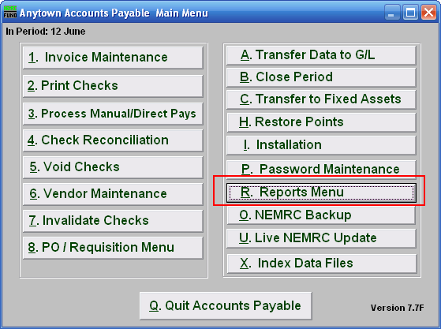
Click on “R. Reports Menu” from the Main Menu and the following menu will appear:
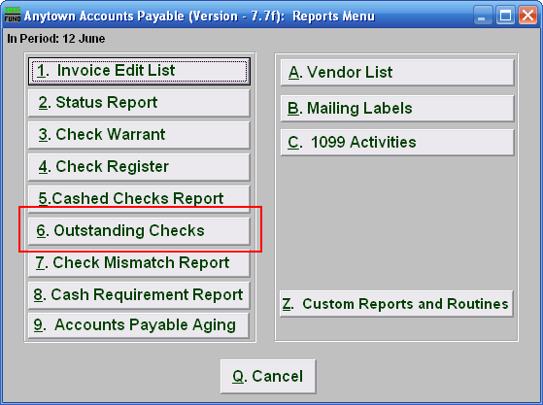
Click on “6. Outstanding Checks” and the following window will appear:
Outstanding Checks

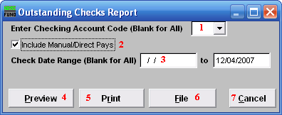
- Enter Checking Account Code (Blank for All): Select the checking account code to report as set up in Installation or leave this field empty to report for all.

- Include Manual/Direct Pays: Check this box to include manual/direct pays made in the date range entered below.

- Check Date Range (Blank for All): Select the beginning and ending check issued dates for collecting data to report.

- Preview: Click this button to preview. Refer to GENERAL PREVIEW for more information.

- Print: Click this button to print. Refer to GENERAL PRINTING for more information.

- File: Click this button to save on this computer. Refer to GENERAL FILE for more information.

- Cancel: Click “Cancel” to cancel and return to the previous screen.

